Programing 1:

import java.util.Scanner;

public class MatrixMultiplicationExample {

public static void main(String args[]) {

int row1, col1, row2, col2;

Scanner s = new Scanner(System.in);

// Input dimensions of First Matrix: A

System.out.print("Enter number of rows in first matrix: ");

row1 = s.nextInt();

System.out.print("Enter number of columns in first matrix: ");

col1 = s.nextInt();

// Input dimensions of second matrix: B

System.out.print("Enter number of rows in second matrix: ");

row2 = s.nextInt();

System.out.print("Enter number of columns in second matrix: ");

col2 = s.nextInt();

// Requirement check for matrix multiplication

if (col1 != row2) {

System.out.println("Matrix multiplication is not possible");

return;

}

int a[][] = new int[row1][col1];

int b[][] = new int[row2][col2];

int c[][] = new int[row1][col2];

// Input the values of matrices

System.out.println("\nEnter values for matrix A : ");

for (int i = 0; i < row1; i++) {

for (int j = 0; j < col1; j++) a[i][j] = s.nextInt();

}

System.out.println("\nEnter values for matrix B : ");

for (int i = 0; i < row2; i++) {

for (int j = 0; j < col2; j++) b[i][j] = s.nextInt();

}

// Perform matrix multiplication

// Using for loop

System.out.println("\nMatrix multiplication is : ");

for (int i = 0; i < row1; i++) {

for (int j = 0; j < col2; j++) {

// Initialize the element C(i,j) with zero

c[i][j] = 0;

// Dot product calculation

for (int k = 0; k < col1; k++) {

c[i][j] += a[i][k] * b[k][j];

}

System.out.print(c[i][j] + " ");

}

System.out.println();

}

}

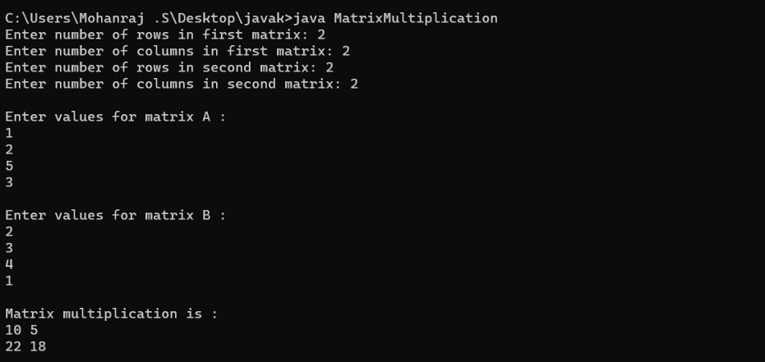}

Programing 2:

import java.util.Scanner;

class Matrix

{

public static void main(String args[])

{

int row, col,i,j;

Scanner in = new Scanner(System.in);

System.out.println("Enter the number of rows");

row = in.nextInt();

System.out.println("Enter the number columns");

col = in.nextInt();

int mat1[][] = new int[row][col];

int mat2[][] = new int[row][col];

int res[][] = new int[row][col];

System.out.println("Enter the elements of matrix1");

for ( i= 0 ; i < row ; i++ )

{

for ( j= 0 ; j < col ;j++ )

mat1[i][j] = in.nextInt();

System.out.println();

}

System.out.println("Enter the elements of matrix2");

for ( i= 0 ; i < row ; i++ )

{

for ( j= 0 ; j < col ;j++ )

mat2[i][j] = in.nextInt();

System.out.println();

}

for ( i= 0 ; i < row ; i++ )

for ( j= 0 ; j < col ;j++ )

res[i][j] = mat1[i][j] + mat2[i][j] ;

System.out.println("Sum of matrices:-");

for ( i= 0 ; i < row ; i++ )

{

for ( j= 0 ; j < col ;j++ )

System.out.print(res[i][j]+"\t");

System.out.println();

}

}

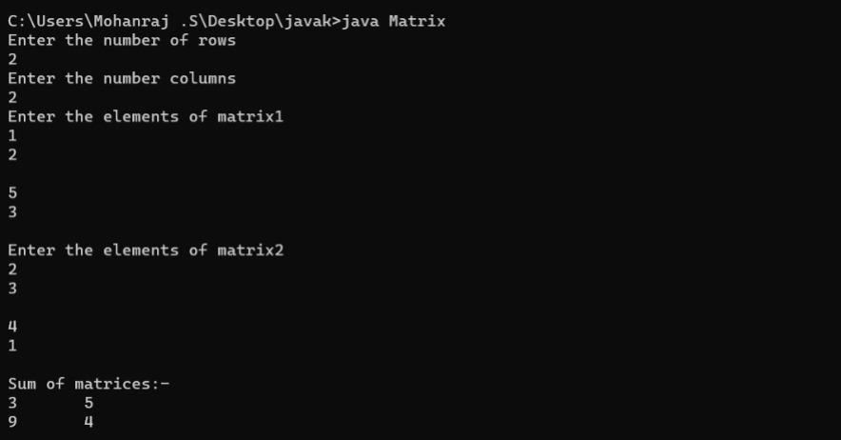}

Programming 3:

mport java.io.*;

import java.lang.*;

class Mean

{

public static void main(String[] args)

{

int[] invalue = new int[]{16,18,27,16,23,21,19};

int num_value=7;

double tot=0;

double mean=0;

for(int i=0; i<num_value; i++)

{

tot = tot+invalue[i];

}

mean = tot/num_value;

System.out.println("The mean value is: "+mean);

//Median calculation

double median = 0;

double mid=0;

if(num_value%2 == 0)

{

int temp=(num_value/2)-1;

for(int i=0;i<num_value;i++)

{

if(temp==i || (temp+1)==i)

{

mid=mid+invalue[i];

}

}

mid=mid/2;

System.out.println("Median value is: "+mid);

}

else

{

int temp=(num_value/2);

for(int i=0;i<num_value;i++)

{

if(temp==i)

{

mid=invalue[i];

System.out.println("Median value: "+mid);

}

}

}

//Mode calculation

int i,j,z, tmp, maxCount, modeValue;

int[] tally=new int[num_value];

for(i=0;i<num_value;i++)

{

for(j=0;j<num_value-i;j++)

{

if(j+1!=num_value)

{

if(invalue[j]>invalue[j+1])

{

tmp=invalue[j];

invalue[j]=invalue[j+1];

invalue[j+1]=tmp;

}

}

}

}

for (i = 0; i < num_value; i++)

{

for(z=i+1;z<num_value;z++)

{

if(invalue[i]==invalue[z])

{

tally[i]++;

}

}

}

maxCount = 0;

modeValue = 0;

for (i = 0; i <num_value; i++)

{

if (tally[i] > maxCount)

{

maxCount = tally[i];

modeValue = invalue[i];

}

}

System.out.println("Mode value is :"+modeValue);

}

}

